You combine the four preferences to get your Myers Briggs personality type code. Eg: having preferences for E, S, T, and J gives a personality type of ESTJ. There are sixteen Myers Briggs personality types:

|  |  |  |  |
| --- | --- | --- | --- |
| [ISTJ](http://www.teamtechnology.co.uk/personality/types/istj/overview/) | [ISFJ](http://www.teamtechnology.co.uk/personality/types/isfj/overview/) | [INFJ](http://www.teamtechnology.co.uk/personality/types/infj/overview/) | [INTJ](http://www.teamtechnology.co.uk/personality/types/intj/overview/) |
| [ISTP](http://www.teamtechnology.co.uk/personality/types/istp/overview/) | [ISFP](http://www.teamtechnology.co.uk/personality/types/isfp/overview/) | [INFP](http://www.teamtechnology.co.uk/personality/types/infp/overview/) | [INTP](http://www.teamtechnology.co.uk/personality/types/intp/overview/) |
| [ESTP](http://www.teamtechnology.co.uk/personality/types/estp/overview/) | [ESFP](http://www.teamtechnology.co.uk/personality/types/esfp/overview/) | [ENFP](http://www.teamtechnology.co.uk/personality/types/enfp/overview/) | [ENTP](http://www.teamtechnology.co.uk/personality/types/entp/overview/) |
| [ESTJ](http://www.teamtechnology.co.uk/personality/types/estj/overview/) | [ESFJ](http://www.teamtechnology.co.uk/personality/types/esfj/overview/) | [ENFJ](http://www.teamtechnology.co.uk/personality/types/enfj/overview/) | [ENTJ](http://www.teamtechnology.co.uk/personality/types/entj/overview/) |

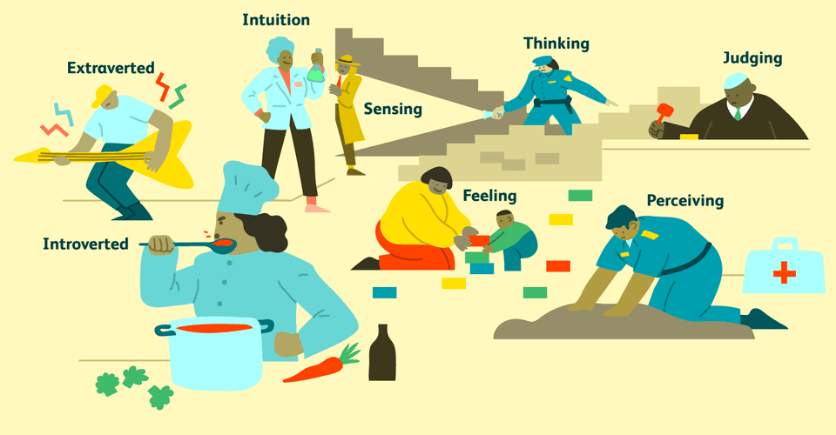

|  |  |  |  |  |  |  |  |  |  |  |  |  |  |  |  |  |  |  |  |  |  |  |  |  |  |  |  |  |  |  |  |  |  |  |  |  |
| --- | --- | --- | --- | --- | --- | --- | --- | --- | --- | --- | --- | --- | --- | --- | --- | --- | --- | --- | --- | --- | --- | --- | --- | --- | --- | --- | --- | --- | --- | --- | --- | --- | --- | --- | --- | --- |
| |  |  | | --- | --- | | **Q1. Which is your most natural energy orientation?**  Every person has two faces. One is directed towards the **OUTER** world of activities, excitements, people, and things. The other is directed inward to the**INNER** world of thoughts, interests, ideas, and imagination.   While these are two different but complementary sides of our nature, most people have an innate preference towards **energy** from either the OUTER or the INNER world. Thus one of their faces, either the***Extraverted*** (E) or ***Introverted***(I), takes the lead in their personality development and plays a more**dominant role** in their behavior. | | | **Extraverted Characteristics**   * Act first, think/reflect later * Feel deprived when cutoff from interaction with the outside world * Usually open to and motivated by outside world of people and things * Enjoy wide variety and change in people relationships | **Introverted Characteristics**   * Think/reflect first, then Act * Regularly require an amount of "private time" to recharge batteries * Motivated internally, mind is sometimes so active it is "closed" to outside world * Prefer one-to-one communication and relationships | | |  |  |  | | --- | --- | --- | | **Choose which best fits**: | **Extraversion (E)** | **Introversion (I)** | | |  |  |  | | --- | --- | | **Q2. Which way of Perceiving or understanding is most "automatic" or natural?**  The **Sensing** (S) side of our brain notices the sights, sounds, smells and all the sensory details of the**PRESENT**. It categorizes, organizes, records and stores the specifics from the here and now. It is **REALITY**based, dealing with "what is." It also provides the specific details of memory & recollections from **PAST**events.  The **Intuitive** (N) side of our brain seeks to understand, interpret and form **OVERALL** patterns of all the information that is collected and records these patterns and relationships. It speculates on **POSSIBILITIES**, including looking into and forecasting the **FUTURE**. It is imaginative and conceptual.  While both kinds of perceiving are necessary and used by all people, each of us instinctively tends to favor one over the other. | | | **Sensing Characteristics**   * Mentally live in the Now, attending to present opportunities * Using common sense and creating practical solutions is automatic-instinctual * Memory recall is rich in detail of facts and past events * Best improvise from past experience * Like clear and concrete information; dislike guessing when facts are "fuzzy" | **Intuitive Characteristics**   * Mentally live in the Future, attending to future possibilities * Using imagination and creating/inventing new possibilities is automatic-instinctual * Memory recall emphasizes patterns, contexts, and connections * Best improvise from theoretical understanding * Comfortable with ambiguous, fuzzy data and with guessing its meaning. | | |  |  |  | | --- | --- | --- | | **Choose which best fits:** | **Sensing (S)** | **iNtuition (N)** | | |  |  |  | | --- | --- | | **Q3. Which way of forming Judgments and making choices is most natural?**  The **Thinking** (T) side of our brain analyzes information in a **DETACHED**, objective fashion. It operates from factual principles, deduces and forms conclusions systematically. It is our logical nature.  The **Feeling** (F) side of our brain forms conclusions in an **ATTACHED** and somewhat global manner, based on likes/dislikes, impact on others, and human and aesthetic values. It is our subjective nature.  While everyone uses both means of forming conclusions, each person has a natural bias towards one over the other so that when they give us conflicting directions - one side is the natural trump card or tiebreaker. | | | **Thinking Characteristics**   * Instinctively search for facts and logic in a decision situation. * Naturally notices tasks and work to be accomplished. * Easily able to provide an objective and critical analysis. * Accept conflict as a natural, normal part of relationships with people. | **Feeling Characteristics**   * Instinctively employ personal feelings and impact on people in decision situations * Naturally sensitive to people needs and reactions. * Naturally seek consensus and popular opinions. * Unsettled by conflict; have almost a toxic reaction to disharmony. | | |  |  |  | | --- | --- | --- | | **Choose which best fits:** | **Thinking (T)** | **Feeling (F)** | | |  |  |  | | --- | --- | | **Q4. What is your "action orientation" towards the outside world?**  All people use both***judging***(thinking and feeling) and ***perceiving***(sensing and intuition) processes to store information, organize our thoughts, make decisions, take actions and manage our lives. Yet **one** of these processes (Judging **or** Perceiving) tends to **take the lead** in our relationship with the **outside world**. . . while the other governs our inner world.  A **Judging** (J) style approaches the outside world **WITH A PLAN** and is oriented towards organizing one's surroundings, being prepared, making decisions and reaching closure and completion.  A **Perceiving** (P) style takes the outside world **AS IT COMES** and is adopting and adapting, flexible, open-ended and receptive to new opportunities and changing game plans. | | | **Judging Characteristics**   * Plan many of the details in advance before moving into action. * Focus on task-related action; complete meaningful segments before moving on. * Work best and avoid stress when able to keep ahead of deadlines. * Naturally use targets, dates and standard routines to manage life. | **Perceiving Characteristics**   * Comfortable moving into action without a plan; plan on-the-go. * Like to multitask, have variety, mix work and play. * Naturally tolerant of time pressure; work best close to the deadlines. * Instinctively avoid commitments which interfere with flexibility, freedom and variety | | |  |  |  | | --- | --- | --- | | **Choose which best fits:** | **Judging (J)** | **Perceiving (P)** | | | |
| **Your 4 Personality Type Letters**   |  |  |  |  | | --- | --- | --- | --- | |  |  |  |  | |

<http://www.humanmetrics.com/cgi-win/jtypes2.asp>